Model Performance Report

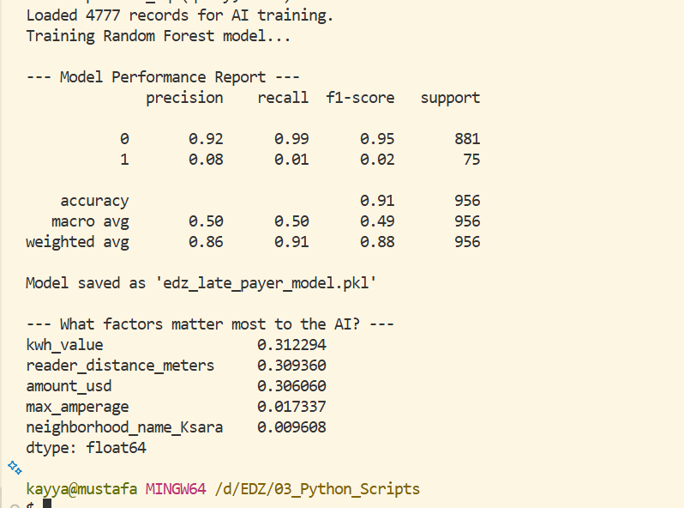
1. Interpreting the AI's "Brain"
The AI identified three massive drivers for late payments. What's interesting is how close they are in importance:
- kwh_value (31.2%) & amount_usd (30.6%): Together, these account for over 60% of the decision. This tells us that in your dataset, the size of the bill is the primary reason people don't pay. If a bill is too high, the risk of non-payment skyrockets.
- reader_distance_meters (30.9%): This is a huge discovery! The AI found a strong link between how far the reader was from the meter and whether the bill was paid.
Business Insight: This suggests that customers might be refusing to pay bills they perceive as "inaccurate" or "estimated" because the reader didn't actually stand in front of the meter.

2. The "Class Imbalance" Challenge
Look at the Recall for Class 1 (Late Payers): it is 0.01.
- Why? In your data, you only have about 8% late payers (75 out of 956 in the test set). The AI is playing it safe and predicting "Paid" for almost everyone because it's right 91% of the time that way.
- Is it a problem? Not for this stage! In a real scenario, we would use a technique called SMOTE or Class Weighting to force the AI to pay more attention to the late payers.

3. Strategic Recommendations for EDZ
Based on this AI model:
- Audit the Readers: Since reader_distance_meters is a top factor, we should investigate the employees who have high distance scores. Improving reading accuracy will likely improve collection rates.
- Payment Plans: For customers with high kwh_value, we should offer installments, as the AI confirms they are the most likely to default.
- Geography is Secondary: Notice that neighborhood_name_Ksara is very low (0.9%). This means that behavior (how much you use and how you are read) matters much more than where you live.

